FIT (173)

PRACTICAL FILE

Name: Divyansh Jha

**ASSIGNMENT - 1**

**Q1. What is an operating system?**

Ans. An operating system is a set of programs that helps us to run our computer system. It acts as a medium between the user and the computer hardware. It helps the user to do basic functions on the computer. With its use the user can give commands to the computer.

Operating system come in two basic forms:- 1) CUI: Character User Interface

In a CUI OS the user interacts with the computer commands in the text form.

2) GUI: Graphical User Interface

In a GUI OS the user interacts with the computer using graphics like images and text.

**Difference between CUI & GUI.**

Ans.

|  |  |  |  |
| --- | --- | --- | --- |
| **Sr. No** | **Key** | **GUI** | **CUI** |
| 1 | Interaction | User interacts with computer using Graphics like images, icons. | User interacts with computer using commands like text. |
| 2 | Navigation | Navigation is easy. | Navigation is difficult. |
| 3 | Input | Keyboard AND Mouse | ONLY Keyboard |
| 4 | Precision | Low precision | High Precision |
| 5 | Speed | Low speed | High speed |
| 6 | Difficulty | Easy | Difficult |
| 7 | Memory | High memory requirement | Low memory requirement |
| 8 | Flexibility | Highly flexible | Little flexible |

**Different types of operating system:**

**Batch Operating System:** In Batch operating system, access is given to more than one person; they submit their respective jobs to the system for the execution. The system put all of the jobs in a queue on the basis of first come first serve and then executes the jobs one by one. The users collect their respective output when all the jobs get executed.

**Multiprogramming Operating system:** Multiprogramming is an extension to batch processing where the CPU is always kept busy. Each process needs two types of system time: CPU time and IO time. In a multiprogramming environment, when a process does its I/O, The CPU can start the execution of other processes. Therefore, multiprogramming improves the efficiency of the system.

**Multiprocessing Operating system:** In Multiprocessing, Parallel computing is achieved. There are more than one processor present in the system which can execute more than one process at the same time. This will increase the throughput of the system. In Multiprocessing, Parallel computing is achieved. More than one processor present in the system can execute more than one process simultaneously, which will increase the throughput of the system.

**Multitasking Operating system:** The multitasking operating system is a logical extension of a multiprogramming system that enables multiple programs simultaneously. It allows a user to perform more than one computer task at the same time etc.

**Distributed Operating system:** These types of the operating system is a recent advancement in the world of computer technology and are being widely accepted all over the world and, that too, with a great pace. Various autonomous interconnected computers communicate with each other using a shared communication network. Independent systems possess their own memory unit and CPU. These are referred to as loosely coupled systems or distributed systems. These system’s processors differ in size and function.

**Different examples of operating system:**

**1. Microsoft Windows:** What Does Microsoft Windows Mean? Microsoft Windows is a group of OSs manufactured by Microsoft. Windows is available in 32 and 64-bit versions and offers a graphical user interface (GUI), multitasking functionalities, virtual memory management capabilities, and support for several peripheral devices.

**2. Linux:** Linux is different from Windows and Apple in that it’s not a proprietary software, but rather a family of open-source systems. In other words, anyone can modify and distribute it. Linux may be the least known on this list, but it’s free and available in many different open-source versions. Linux is popular because of its ease of customization and offers a variety of options. If you know how to customize and work with operating systems, Linux is an ideal choice.

**3. Apple IOS:** Apples iOS is another mobile operating system used exclusively for iPhones, some of the most popular mobile devices on the market. iOS integrations have regular updates, new expansions to software, and continually are offering new features for users even if they have older devices. Many users appreciate the unique user interface with touch gestures, and the ease of use that iOS offers. This operating system also allows other Apple devices to connect, giving users easy connections to other devices or people.

**4. Google’s Android OS:** The OS that companies including Google use to run its Android mobile smartphones and tablets is based on Linux distribution and other open-source software. Android OS is the primary OS for Google mobile devices like smartphones and tablets. Android has gained increasing popularity since its release as an alternative to Apple’s iOS for smartphone users and is continuing to increase in popularity with new updates and exciting features.

**5. Apples macOS:** Head-to-head in the competition with Microsoft Windows is Apple’s macOS. macOS and Windows are both examples of proprietary operating systems, meaning that the company conceptualized, designed, developed, and now sells their own OS. They’re designed and sold by the companies and aren’t meant to be tampered with or tweaked by users. Apple and Macintosh computers run on the proprietary macOS and OS X system, the first of which launched 20 years ago.

**6. Parrot OS:** Parrot OS is an open source and free GNU/Linux Distribution based on Debian testing designed for security experts, security aware people and developers. It involves a full portable arsenal for IT security and digital forensics operations. It includes everything you need to develop your own programs or protect your privacy while surfing the net etc are the best example of general work and safety OSs.

**ASSIGNMENT-2**

**Q2. What is MS DOS? Write down the function of the commands used in DOS and their syntax (date, time, label, path, vol, help, exit, cls, dir file, directory commands, copy con, type, cd, md, rd, erase, ren, copy, move, find, delete, xcopy, tree, fc, checkdisk, sort).**

**Ans.** Short for Microsoft Disk Operating System, MS-DOS is a non-graphical command line operating system derived from 86-DOS that was created for IBM compatible computers. MSDOS originally written by Tim Paterson and introduced by Microsoft in August 1981 and was last updated in 1994 when MS-DOS 6.22 was released. MS-DOS allows the user to navigate, open, and otherwise manipulate files on their computer from a command line instead of a GUI like Windows.

**Some of the DOS internal commands are:-**

• **copy con** :- It makes new files.

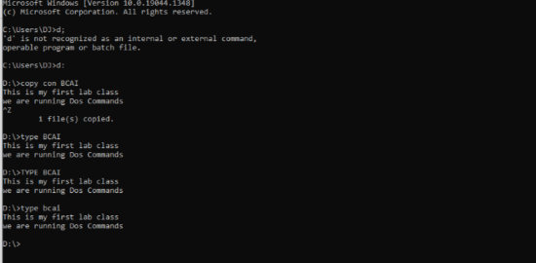

• **^Z** :- save and exit.



• **type** :- it prints the text in a file.



• **date** :- it shows us the current system date and allows us to change the date.

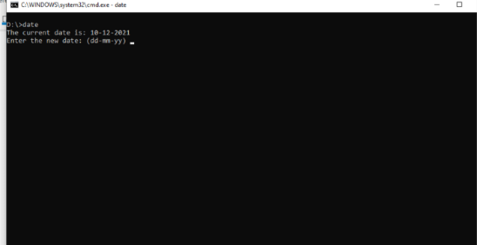

• **time** :- it shows us the current system time and allows us to change the time.

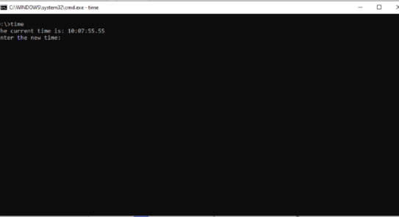

• **cls** :- it clears the screen.

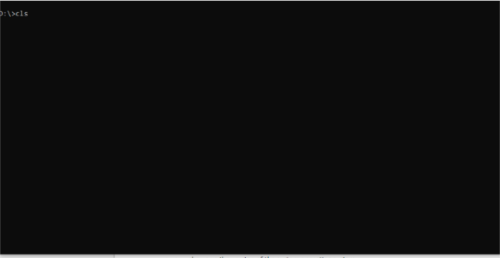

• **ver** :- shows us the version of the system operating system

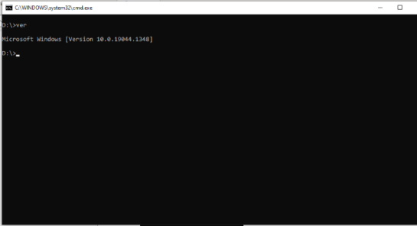

• **vol** :- shows us the volume information of our drive

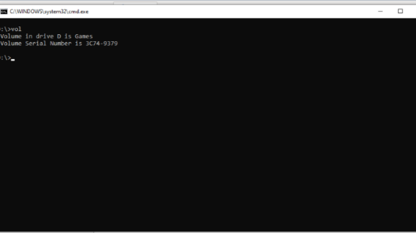

**Assignment – 3**

**Q3. Explore windows explorer functionalities like create, rename, move, delete folders and files.**

Ans. Windows is one of the most famous operating system which is being used world-wide by a billion+ people. It was developed by Microsoft. It has one of the easiest GUI that what makes is one of the best. It provides many functions that a person can work upon easily.

**Some functions in Windows**

• **Rename**: We can rename a file or a folder by a few different ways like Right-Clicking on the file/folder and clicking on the rename function.

• **Create**: To create a new file or folder we can right click on any folder or on the desktop and click on the new option and then select a folder or the kind of file that we want to create.

• **Cut**: We can use the cut function to copy a file/folder/text etc. To the clipboard and delete it from its original location. By right-clicking on it and selecting cut. Or select it and press ctrl+x

• **Copy**: We can copy a file/folder/text etc. to the clipboard. By right-clicking on it and selecting copy. Or select it and press ctrl+c

• **Paste**: We can paste the most recent file/folder/text copied/cut to the clipboard anywhere. By right-clicking on it and selecting Paste. Or select it and press ctrl+v

• **Explore & Search**: In windows 10, if you press the Windows button, it opens explore and search. We can search for anything on the computer or on the web just by typing it on our keyboard.

• **Properties**: If you right-click on any file/folder and select properties, it will open the properties dialog box. It shows all the detail about the selected file/folder like its location, size, type, creation date, last modified date.

• **Shortcut**: We can create a shortcut for any file/application/folder and put it in any place that we like, to easily access the file without changing its original location.

• **Open:** We can open any file/folder by double left-clicking or right clicking and selecting open on it.

**Assignment – 4**

**Q4. Practice the use of basic formatting features- Formatting Painter, Indentation, Line spacing, Background color, Find, Replace, Dictate commands.**

Ans. Ms-Word is a text editor and one of the many useful software developed by the Microsoft. This is used to make files, document and do lot of different paper works digitally. It provides many features and functions to edit and format the text and give them better looks and designs. Here below are the some of the basic featured than one can use to format his/her text:

**1. Format Painter-** This feature is used to copy the format of one type of text and apply that format on other text that we select. In the picture below we can see that we have written a para and first few words are in different format than other para text and the para below it we used the format printer feature to apply that format to other text. Use: Select the text format you want to apply. Then click on format printer and then select the text you want to apply on.

**2. Indentation:** This feature is used to give indentation from different sides of the pages like- right, left, center, justification. Below are the examples: Right- select the para and then select the right indent option in Paragraph tab.

**Left-** Select the para and go to the left alignment in the para tab in home.

**Center:** Select the text and select the center alignment in para tab in home.

**Justify:** Select the text and select the justify option in para tab in home.

**3. Line spacing:** This feature is used to adjust spaces between the lines of the text. To do so we select the para and go to the para tab and select the line spacing option.

**4. Background color:** This feature lets us to change and set the background color of the page as we wish to.

**5. Find:** With this feature we can find any word in the word document. After that we can also replace the word with other. Go to the home tab and in the tool bar there are options in the last part. There you can select find and you can find any word you are looking for.

**6. Replace:** With this option we can replace a word with other by searching the word. In home tab it is also in the last part, click on it and search the word to replace and choose the option to replace (only one or all).

**Assignment – 5**

**Q. To practice the use of Bullets, Numbering, Multilevel lists and use of Table Features- Insert table with rows and columns, draw tables, excel spreadsheets and quick access tables etc.**

**a) Write a short note on the different types of memory and show the use of bullets, numbering and multilevel lists.**

**b) Draw a timetable using Insert Table.**

**c) Create a table in MS-Word with the following entries: S. No, Student Name, Subject 1, Subject 2, Subject 3, Subject 4, Subject 5 and apply the following operations on it.**

**i.**  **Calculate the minimum marks in Subject 1 & Subject 3.**

**ii.**  **Calculate the maximum marks in Subject 2 & Subject 5.**

**iii.**  **Find the sum of total marks obtained in each subject.**

**iv.**  **Insert a new column named grade in the Table.**

**v.**  **Sort the table with respect to the column avg.**

**vi.**  **Covert the table into text.**

**ANS.**  a) Computer is an electronic machine and human use it for many work and in that case computer requires memory to store that data. That’s why computer has mainly two types of memory:

**1. Primary Memory:** This memory contains two different types of memory.

(1) RAM: It performs function to run the programs and can access any content according to the user that’s why the name RAM . It also contains two main types of RAM.

(a) Static RAM

(b) Dynamic RAM

(2) ROM: It stores data that cannot be written but read. It also has different types:

(a) ROM- Read Only memory

(b) PROM- Programmable Read Only memory

(c) EPROM- Electrically Programmable Read Only memory

(d) EEPROM- Electrically Erasable and Programmable Read Only memory

**2. Secondary Memory:** These are the mainly used for permanent storage devices and there are different types of secondary storage.

* 1. CDs
  2. Magnetic Disks
  3. Pen-drives
  4. DVDs
  5. Floppies
  6. Hard disks

(1) HDD

(2) SSD

**To do the above formatting we can access Paragraph tab in home tab.**

STEPS:

1. Go to home tab

2. Go to Paragraph section

3. Hover over the different items there you can find different types of bullets, numbering and multilevel listing format in the first row starting from left.

**b) Timetable using insert table:**

To insert a table, we use insert tab:

1. We go to the insert tab.

2. There in the most left corner we can see the table option.

3. On clicking on it, we can find the tables rows and columns to insert.

4. We can insert as many rows and columns as we want by customizing it.

|  |  |  |  |  |  |  |
| --- | --- | --- | --- | --- | --- | --- |
| Days/Time | MON | TUES | WED | THURS | FRI | SAT |
| 8:30 | FIT | FIT | FIT | FIT | FIT LAB | WT |
| 9:30 | C | C | WT | WT | WT LAB | C |
| 10:30 | WT LAB | WTLAB | C LAB | C LAB | WT | FIT LAB |
| 11:30 | WT LAB | WTLAB | C LAB | C LAB | ACTIVITY | FIT LAB |
| 12:30 | BREAK | | | | | |
| 1:30 | DM | DM | TC | TC | DM | DM |
| 2:30 | TC | TC | C |  |  |  |

**C) Table**

|  |  |  |  |  |  |  |
| --- | --- | --- | --- | --- | --- | --- |
| **S No.** | **Student Name** | **Subject 1** | **Subject 2** | **Subject 3** | **Subject 4** | **Subject 5** |
| **1** | **Komal** | **75** | **85** | **69** | **24** | **82** |
| **2** | **Rahul** | **87** | **47** | **86** | **85** | **89** |
| **3** | **Gaurav** | **54** | **84** | **67** | **96** | **63** |
| **4** | **Sahil** | **94** | **96** | **89** | **92** | **94** |
| **5** | **Nisha** | **45** | **65** | **25** | **35** | **85** |

**As we already have described how to insert a table let us see how to use different function of tables.**

**Using formula functions:**

* Go to tables and insert a table.
* Now there comes two option
* Table design and layout.
* In the layout option we can chose the formula function to operate upon table’s data.

1.Calculate the minimum marks in Subject1 & Subject 3.

Using the formula function to calculate minimum:

* Go to the formula tool in the layout tab.
* Choose the minimum function and enter the location of the data where it lies in the table
* left, right, above, below.

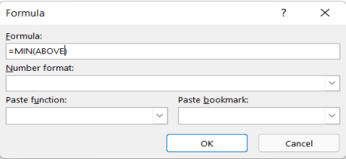

**ASSIGNMENT-6**

**Q. Create a pamphlet of a company and explain insert tab in detail.**



**Insert tab:**

**• Pictures tool** used to insert picture.

i) Go to insert.

ii) Got to pictures.

iii) Choose pictures to find insert – from device or from online.

iv) Choose the picture you want to insert and click insert option.

**• Text box** tool used to insert a text box that makes you able to write some text inside it on any location.

i) Go to insert.

ii) Go to text box.

iii)Click on text box and insert it.

iv) Type and format text in any style using shape format tools

**• Smart art** used to show flow charts and procedural (step wise) things.

i) Go to insert.

ii) Go to smart art.

iii)Choose any art design.

iv) Edit the text in it to show the procedural info.

v) We can also edit the smart art block design by right clicking on it.

• Word art used to make text attractive and designer.

i) Go to insert.

ii) Select the text you want to edit with word art.

iii)Go to word art choose the word art. It will be applied on it.

**• Charts** are used to represent graphical data.

i) Go to insert.

ii) Select the data you want to represent.

iii)Select the graph.

iv) Insert it.

• Equations are used to insert some mathematical equations in document. i) Go to insert.

ii) Go to equations tool provided in the extreme right.

iii)Select the equation you want to use.

iv) You can choose other options to insert extra equations.

• Symbols are used to insert the special symbols that are not provided in the keyboard.

i) Got to insert.

ii) Got to the extreme right there you can find the symbols.

iii)Select the symbols you want to use in the doc.

**Design tab:**

• Page color used to give color to page.

i) Go to Design tab.

ii) Choose the page color tool.

iii)Choose the color you want to add in page.

• Page border is used to insert border in page.

i) Go to design tab.

ii) Choose the page border provided in the extreme right.

iii)There you can set- thickness, color, stylish, and artful borders.

• Watermark is used to give a faint text behind the main content of the document. Like we have seen in the confidential docs.

i) Go to design.

ii) Go to watermark.

iii)Choose any water mark you want to use in your doc.

iv) You can also customize your own watermark text in custom watermark option.

**ASSIGNMENT-7**

**Q. To practice the use of Layout Features – Margins, Orientation, Size, Columns, Indent, Spacing etc.**

**Cover page :**

1) Go to insert.

2) At the extreme left there is an option of Cover page.

3) Choose cover page that you would like to insert.

**Page break:**

1) Go to insert.

2) At the extreme right there is given page break.

3) Put the curser from where you want to break the page and click on the page break.

**Date and time:**

1) Go to insert.

2) Choose Date and time.

3) Select the format of Date and time you want to insert.

4) You can set the default time and date.

**Margins:**

1) Go to layout.

2) Click on margins.

3) Select the margins for your page or you can customize margins.

**Orientation:**

1) Go to layout.

2) Click orientation.

3) Choose the orientation you want to apply.

**Text box:**

1) Go to insert.

2) Add a text box and you can apply and end note.

**Line number:**

1) Go to the page in which you want to insert page number.

2) Go to layout.

3) Select line number.

**ASSIGNMENT-8**

**Q. To practice the use of mail Merge Feature to generate Envelops and Labels.**

**Mailing:**

1) Go to Mailings tab.

2) Go to start mailing and click on step-by-step mailing.

3) A mailing wizard will pop up in right side of the window. This will lead you to all the steps of the of mailing.

**Step by Step mailing:**

1) See on the right bottom corner and Start with a document.

2) Select the recipients list- you can use an exiting list or create your own new list.

3) After creating the recipient list, select an existing document or create a letter.

4) Now add the merge fields where in the format you want to insert.

5) After inserting the merge fields preview the letters. You can to other letters and preview using the option given in preview results.

**Envelope:**

1) To create envelopes, you can choose two options.

i) First-to choose the envelope option that will create only one envelope.

ii) Second-to choose from Start mailing option that will create no of envelopes for every recipient.

**ASSIGNMENT-9**

**Q. Create your Resume using formatting features like: tables, bullets, word art etc. Check the spelling and grammar in an existing document and it should be properly aligned with proper format.**

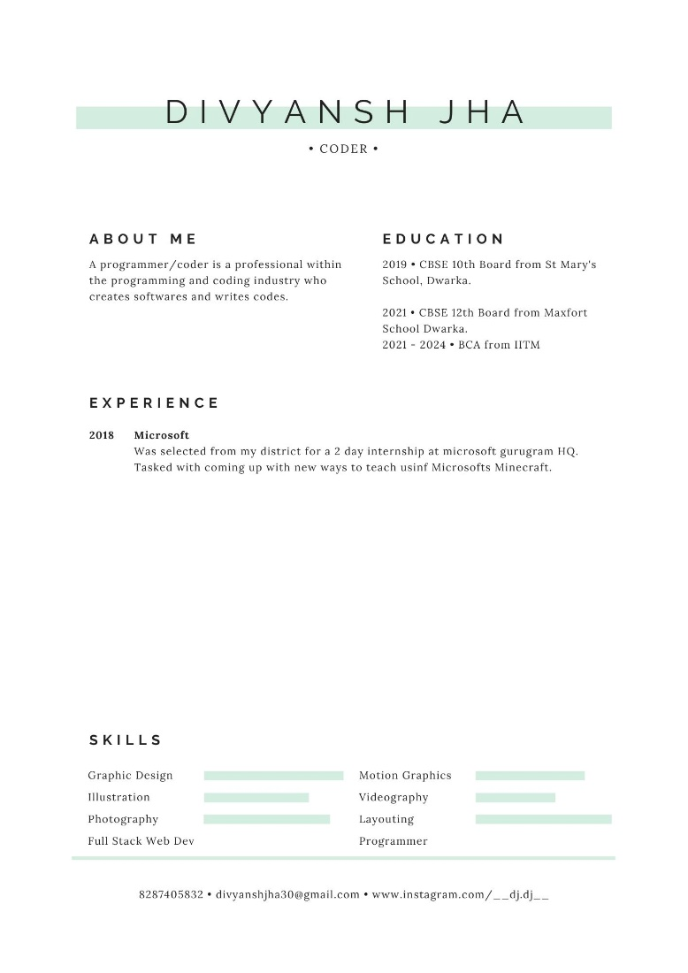

**ASSIGNMENT-10**

**Q. Write an article with three columns and create a hyperlink for it.**

**Article:-**

**AI**

**AI generally is undertaken in conjunction with machine learning and data analytics. Machine learning takes data and looks for underlying trends. If it spots something that is relevant for a practical problem, software designers can take that knowledge and use it to analyze specific issues. All that is required are data that are sufficiently robust that algorithms can discern useful patterns. Data can come in the form of digital information, satellite imagery, visual information, text, or unstructured data.**

**Adaptability**

**AI systems have the ability to learn and adapt as they make decisions. In the transportation area, for example, semi-autonomous vehicles have tools that let drivers and vehicles know about upcoming congestion, potholes, highway construction, or other possible traffic impediments. Vehicles can take advantage of the experience of other vehicles on the road, without human involvement, and the entire corpus of their achieved “experience” is immediately and fully transferable to other similarly configured vehicles. Their advanced algorithms, sensors, and cameras incorporate experience in current operations, and use dashboards and visual displays to present information in real time so human drivers are able to make sense of ongoing traffic and vehicular conditions. And in the case of fully autonomous vehicles, advanced systems can completely control the car or truck, and make all the navigational decisions.**

**Create a Hyperlink:**

1) Type a text in the document that you want to create as a hyperlink and attach a document to. As for example I created this AI ARTICLE text a hyperlink for the above document. So, if you will click on the text, it will open that document.

2) Now select that text.

3) Now go to the insert tab.

4) Click on the HYPERLINK tool or simply LINK.

Your text will display in the Text to Display box.

5) Now select the document or file you want to attach to that text from the below mentioned files (or you can browse files also).

6) Copy the path in the address box given in the bottom of the dialog box.

7) Click ok.

**Your selected text will turn blue, Done**